# AIM: Explore the Microsoft Project tool and explain the characteristics and scheduling with GANTT chart and PERT Chart.

## Microsoft Project Tool:

* Microsoft Project tool is a project management software product, developed and sold by Microsoft. It is designed to assist a project manager in developing a plan, assigning resources to tasks, tracking progress, managing the budget, and analyzing workloads.
* Microsoft Project was the company's third Microsoft Windows-based application, and within a couple of years of its introduction it became the dominant PC-based project management software.
* It is part of the Microsoft Office family but has never been included in any of the Office suites. It is available currently in two editions, Standard and Professional. Microsoft Project's proprietary file format is “.mpp”.
* Microsoft Project and Microsoft Project Server are the cornerstones of the Microsoft Office enterprise project management(EPM) product.
* The first commercial version of Project was released for DOS in 1984. Microsoft bought all rights to the software in 1985 and released version 2. Version 3 for DOS was released in 1986. Version 4 for DOS was the final DOS version, released in 1986. The first Windows version was released in 1990 and was labelled version 1 for Windows.
* In 1991 a Macintosh version was released. Development continued until Microsoft Project 4.0 for Mac in 1993. Microsoft Project 4 for the Mac included both 68k and PowerMac versions, Visual Basic for Applications and integration with Microsoft office 4.2 for the Mac. In 1994, Microsoft stopped development of most of its Mac applications and did not offer a new version of Office until 1998, after the creation of the new Microsoft Macintosh Business Unit the year prior.
* The Mac Business Unit never released an updated version of Project, and the last version does not run natively on Mac OS X.

## Characteristics and Scheduling with GANTT chart and PERT Chart:

* PERT stands for Program Evaluation and Review Technique. A PERT chart illustrates a project as a network diagram. The U.S. Navy created this tool in the 1950s as they developed the Polaris missile (and time was of the essence—this was during the Cold War, after all). Project managers create PERT charts to analyze the tasks and minimum time necessary to complete a project.
* PERT charts are generally used before a project begins to plan and determine the duration of each task—so they don’t have to show the actual dates of your project. They also do a better job of showing whether certain tasks need to be completed in order or whether they can be completed simultaneously. Use a PERT chart if you need to:
  + Show the interdependency of certain tasks.
  + Anticipate the amount of time it’ll take to complete a project.
  + Determine the critical path to meet your deadlines.
  + Plan for large or more complex projects.
* You can design your PERT chart in a few different ways. The traditional PERT chart (also known as an activity-on-arrow diagram) contains two different elements:
  + Nodes represent events or milestones in your project. You can use either numbered circles or numbered boxes.
  + Arrows represent tasks. The direction of the arrows shows the sequence of tasks. Diverging arrows indicate that you can complete those tasks concurrently. In the example below, tasks 1, 2, 4, and 6 have to be completed in order.
* Both visualizations deal with project management, but you should consider some key differences between Gantt charts and PERT charts before you decide which will work better for your project.

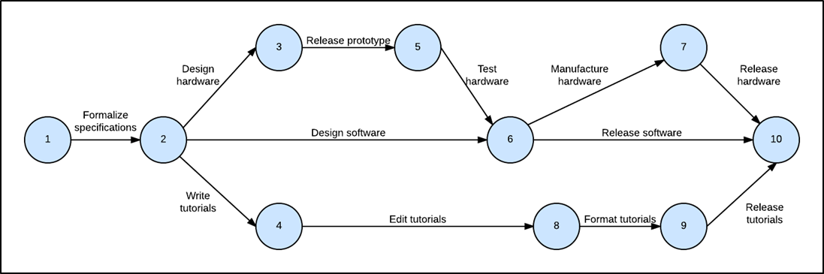

* Like PERT charts, Gantt charts break projects into smaller tasks and highlight scheduling constraints. However, project managers use Gantt charts while a project is happening—they schedule tasks by date and show how much work has been completed. Every activity is represented with a bar that stretches from the start date to the end date of that activity.
* When you and your team need to complete a project, you’ll realize that there are a ton of diagrams you could use for project management. Work breakdown structures help you split your project into manageable pieces. Gantt charts help you see the progress your team has made. But only one diagram can do it all.
* A PERT chart allows you to break a project into smaller tasks, estimate the time necessary to complete each task, and keep your project on track. Learn more about PERT charts, including the differences between Gantt charts and PERT charts and the steps to build an effective PERT chart.

